PROJECT REPORT TEMPLATE

**1. INTRODUCTION**

**1.1 Overview**

Zoho Book is a cloud-based accounting software that can help manage finances and accounting for businesses like Keerthi Sweets. It can be used for tasks such as invocing, expense tracking, inventory management, and more.

1. My project title was "Preparatuon and maintenance for Keerthi Sweets" in ZOHO books.

2. My project duration was 28 days. I finihed my project in 2 days after the starting days.

**1.2 Purpose**

1. Account maintained easily.

2. Time saving.

3. It is an easy way to create sales, purchase order, bills and invoices.

**2. Problem definition and deign thinking:**

**2.1 Empathy map**

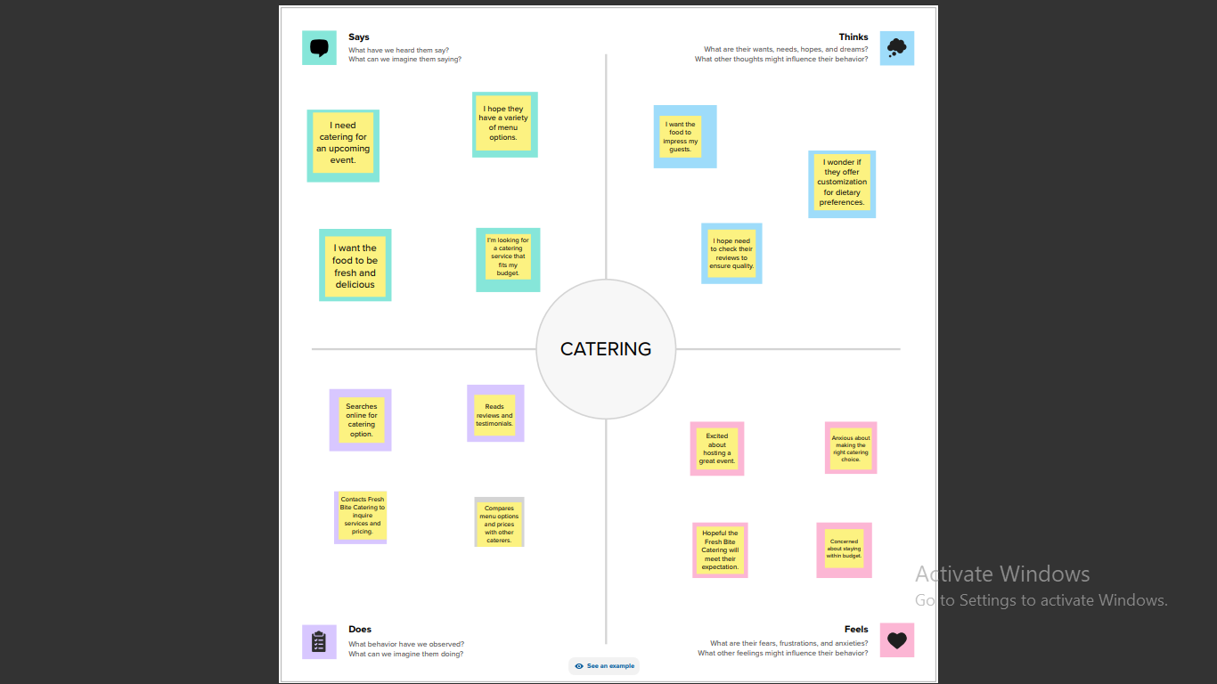

**2.2 Idea and Brainstorming map**

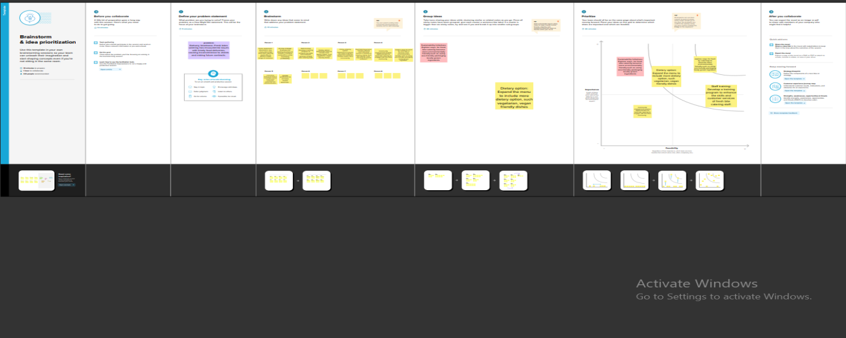

**3. Result**

In the result, I can find out

**ITEMS CREATION**

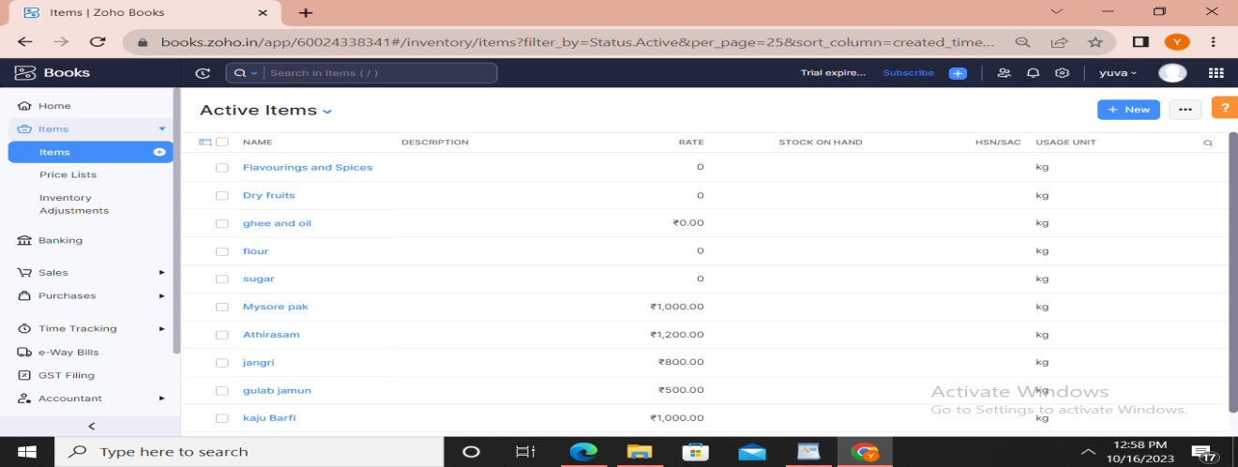

**VENDOR CREATION**

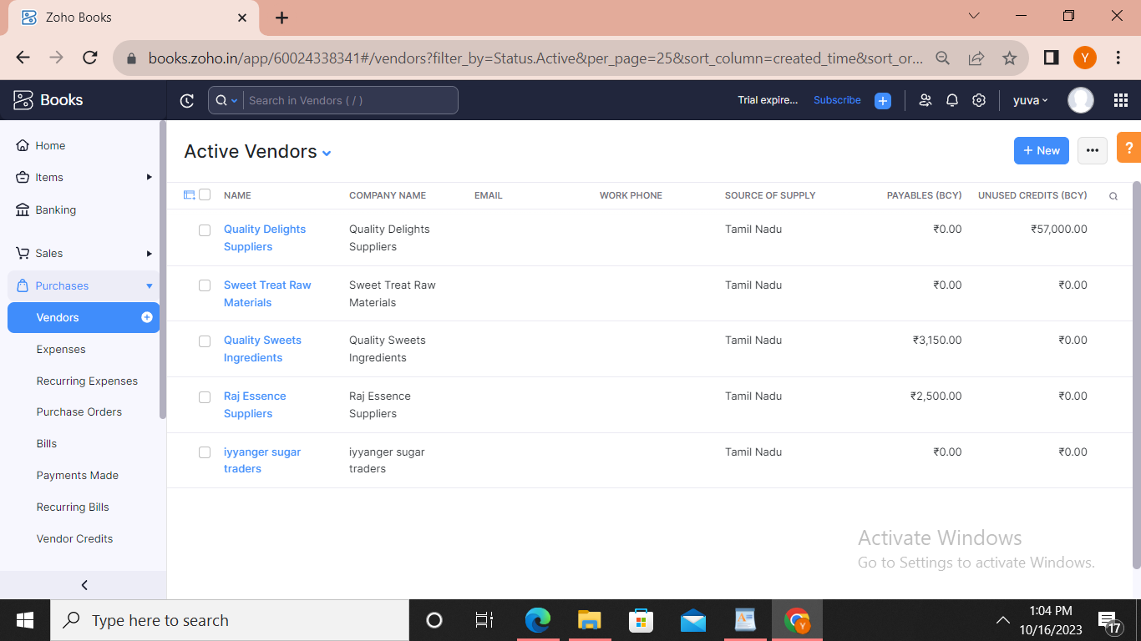

**PURCHASE ORDER**

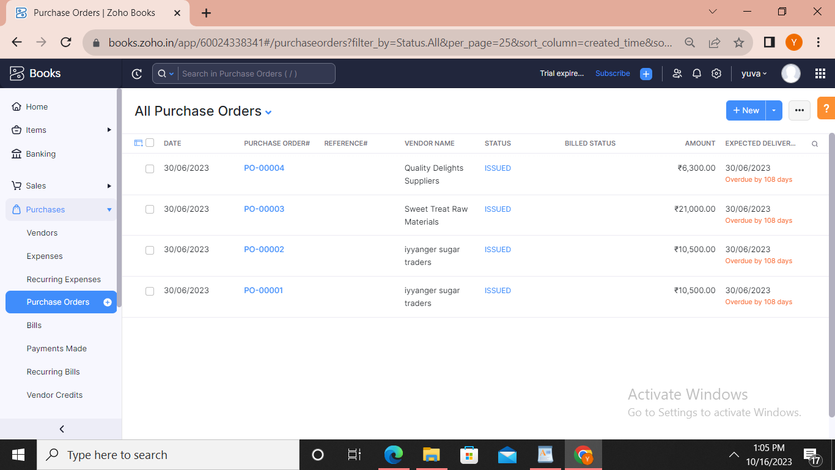

**SALES ORDER**

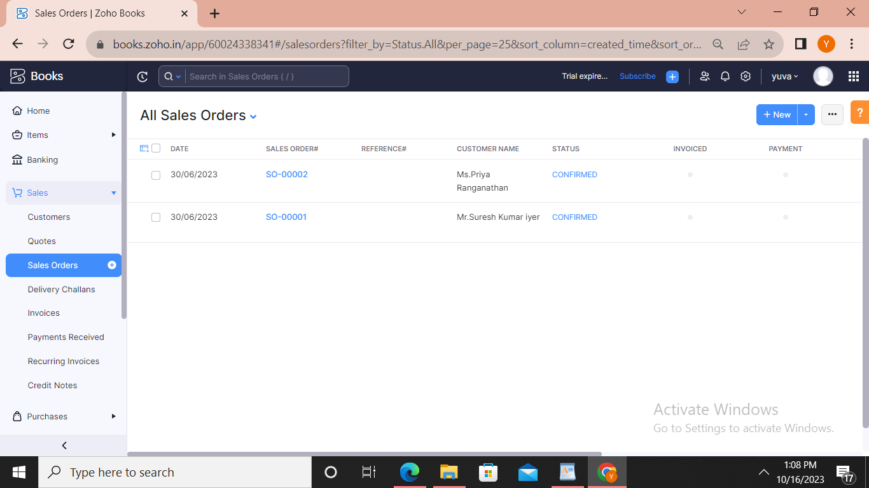

**BANK DETAILS**

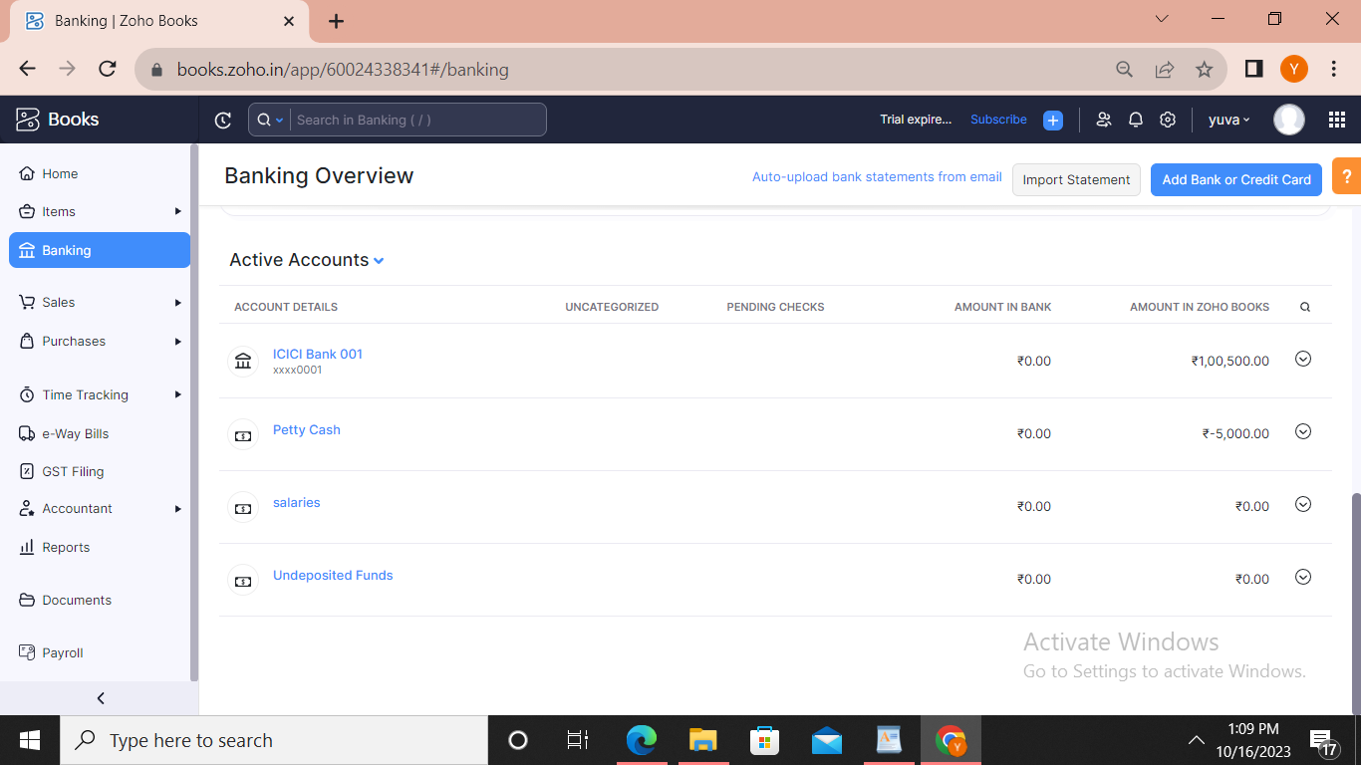

**PROFIT AND LOSS ACCOUNT**

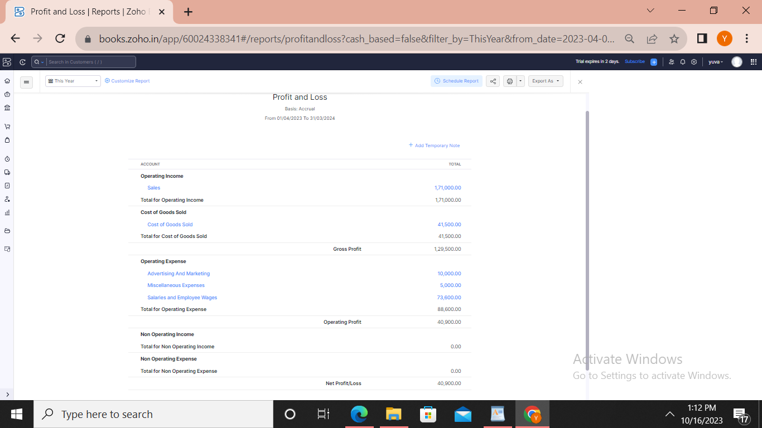

**BALANCE SHEET**

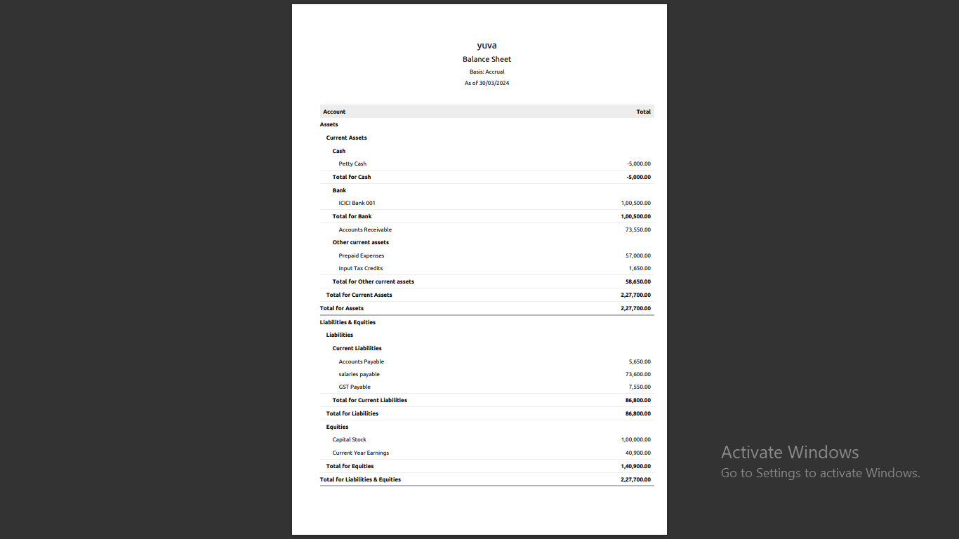

**4. Advantage and dis advantage**

**Advantages:**

1. Accounts maintained easily.

2. Time saving.

3. It is an eassy way to create sales,purchase order, bill and invoices.

**Disadvantages:**

1. We cannot see the customer and to talk over the customers.

**5. Applications:**

ZOHO Books link: book.zoho.com

**6. Conclusion:**

1. First we open the link and we create the organization name.

2. The zoho books page opened, first we create the items.

3. Then ,sales creation and purchase creation.

4. Now to create vendors, purchase order, bills and invoices, customers, adding bank account, new accounts and ledger, journal entries, recording banking transactions.

5. To see the reports what we can created and recorded.

**7. Future scope:**

1. Group scope provided complete access to all functions the user can perform on the record.

2. For instance, a group scope can allow a user to read, create, update and delete records in all modules.

3. The user has access to all modules in the client ZohoCRM account.

**8. Appendix:**

**Computer data**